Power Laws

# Abstract

An incandescent lightbulb works by heating a tungsten filament until it glows. All matter emits electromagnetic radiation, called thermal radiation, when it has a temperature above absolute zero. In this report we present how we performed an experiment to compare the blackbody power law: I ∝ V^(3/5) and the power law for a tungsten wire: I ∝ V^0.5882, to the model power laws we estimated from our data: measuring voltage and current in a circuit with a lightbulb. These theoretical power laws are graphically compared with our model power laws. Furthermore, to determine the quality of our models, we calculate the reduced Chi squared values of each model. We also confirmed that the theoretical voltage exponent values fell within the uncertainty range of our estimated model exponent values. This analysis was done in Python with use of the numpy, scipy and matplotlib modules.

# Introduction

In this exercise we will model the relationship between voltage and current flowing through a circuit with a lightbulb. The corresponding theoretical power law for a radiating blackbody is: I ∝ V^(3/5), while for a tungsten wire, it is approximately: I ∝ V^0.5882. Here I is the measured current, and V is voltage. In our experiment, V is the independent variable, and I is the dependent variable.

We will use two models to approximate the power law from our data: I = a*V^b will be our non-linear model, and: ln(I) = a*ln(V)+b the linear model for which we will fit to our data. a and b are parameters to be adjusted for a best fit, while V and I are our measured values of voltage and current. ln is the natural logarithm.

# Methods, Materials and Experimental Procedure

We successfully followed the procedures as described in the exercise3.pdf document.

# Results

Below in Figure 1 and 2, we see our data from the experiment plotted as points with corresponding error bars. Furthermore, we see the theoretical curves as described in the introduction, along with the curves corresponding to our two models best fitted to our data. The two models are so similar that it is hard to distinguish them in the plots below.

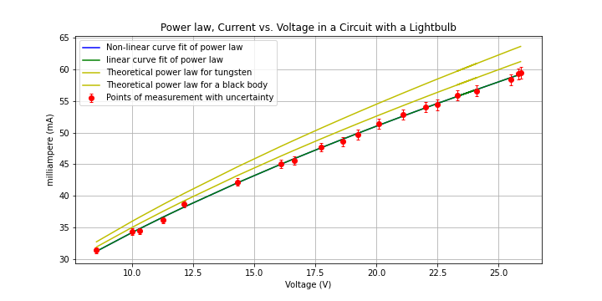

*Figure 1: Points of measurement with corresponding error bars, theoretical power laws for   
 tungsten and a blackbody, along with our two power law models best fitted to our data   
 points.*

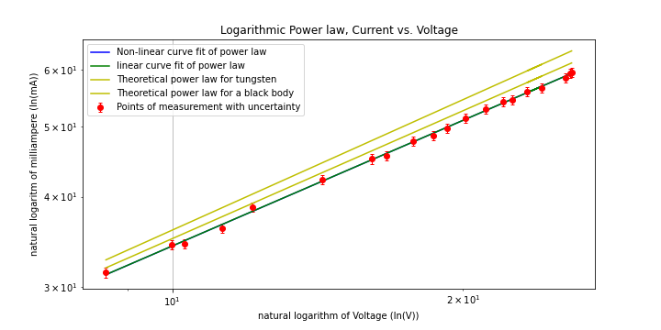

*Figure 2: Equal to Figure 1, though with logarithmic axes.*

The optimal parameters with variance, estimated by the scipy optimize curve fit function, are:   
[a,b] = [0.57787573 2.20117518] +- [0.00989301 0.02841001] for the linear model, and:   
[a,b] = [9.03211882 0.57799121] +- [0.25674234 0.00989844] for the nonlinear model.

The reduced Chi squared values for the nonlinear and linear model respectively are 0.19 and 0.19.

The power laws we found between current and voltage, was, with our non-linear model:

I(V)= 9.0321 * V ^ 0.5780

For our linear model, we found:

2.2012 * exp( 0.5779 * V ),

Where V is the measured voltage (in volts) and I is current (in milliampere).

# Discussion

The uncertainties of the measured current, our dependent variable, were initially estimated by picking the maximum uncertainty caused by accuracy and precision. The uncertainty of accuracy was caused by the ammeter we used in our experiment. The manufacturer of the ammeter writes in its manual that there is an estimated measurement uncertainty of 0.75% of the value measured by the ammeter. The uncertainty of precision was caused by variation over time of the last digit of the measured current of the ammeter. The last digit in our experiment was the first decimal place with milliampere units, so we estimated an uncertainty due to precision of 0.1 milliampere. Our initial estimates of the uncertainty, corresponding to each data point in our experiment, was the maximum of the uncertainty due to precision, and accuracy.

However, with these uncertainties our model curves did not pass through the error bars of each data point in the experiment. To solve this problem, we had to multiply the uncertainty by a factor of 2. The result is shown in Figure 1 and 2 in the Results section.

The reduced Chi squared values calculated for each model, see the Results section, are acceptable values. Thus, the spread (Euclidian distance) between our data points and our two model curves are low. This is good. However, the reduced Chi squared values are perhaps a bit too small. In our next experiment we will consider gathering more data to increase the reduced Chi Squared values of our models. We were taught in our labs that a reduced Chi squared value should ideally be approximately between 1 and 10, in experiments such as our own.

As seen in Figure 1 and 2, both models produce approximately the same curve, which fit our data well. However, the theoretical curves describing the power law, current vs. Voltage, for a tungsten lightbulb and a blackbody, both deviate somewhat from our data points and curves. We have programmed the theoretical curves to only differ from the non-linear model curve, by the value of the Voltage exponent.

The exponents of our two models are very close to the theoretical exponents. By the theoretical power laws, with tungsten and blackbody respectively, current is proportional to voltage to the power of 0.5882 and 3/5=0.6. While the nonlinear model approximates an exponent of 0.5778 +- 0.51, while the linear model also approximates an exponent of 0.5779 +- 0.17. These uncertainties are calculated as the square root of the parameter variances of our models returned by the scipy curve fit function. Thus, the values of our fitted exponent fall within the range of the blackbody values (3/5=0.6) and the expected value for tungsten (0.5882), with our calculated standard deviation.

These small deviations in model exponents, in comparison to theory exponents, causes the theoretical curves to deviate from our model curves.

# Conclusion

In this exercise we estimated the power law of a lightbulb in a circuit by measuring current and voltage with uncertainties. We successfully followed the instructions for the experiment written in the exercise3.pdf document without issues. Our results show that both our models return approximately the same estimated power law. However, this power law deviates somewhat from the theoretical power laws for a radiating blackbody and a tungsten wire. We have plotted our data, our model and theoretical curves, and calculated each models reduced Chi squared values.

# References

exercise3.pdf

# Appendices

The code and data we wrote for this experiment is shown below in Code 1 and Data 1.

#Importing modules

import numpy as np

import matplotlib.pyplot as plt

import Functions as F

#Defining model function for position prediction

def linear_model(x,a,b):

return a*x+b

def non_linear_model(x,a,b):

return a*x**b

#Importing data from csv file

Voltage, Current = np.loadtxt('Data.csv',skiprows=1,

delimiter=', ', unpack=True)

#To find the uncertainty of the current measurements, we choose the larger

#uncertainty of the precission (fluctuations of the last digit) and

#accuracy (instrument error) uncertainty.

def return_uncertainty(A):

U_acc = 0.0075*A

U_pre = 0.1

if U_pre >= U_acc:

U = U_pre

else:

U = U_acc

return U * 2 #added a factor of 2 to our uncertainty

#Creating a list of uncertainties associated with each

# y-value/current measurement.

Uncertainty = []

for i in Current:

Uncertainty.append(return_uncertainty(i))

#Now we fit the parameters of the two models to our data:

popt_linear, pstd_linear = F.fit_data(linear_model,

np.log(Voltage),

np.log(Current),

Uncertainty/Current,

[0.57710934, 2.20315259])

popt_non_linear, pstd_non_linear = F.fit_data(non_linear_model,

Voltage,

Current,

Uncertainty,

[9.05001068, 0.57722491])

print("The estimated optimal parameters with uncertainty by scipy optimize",

"curve fit are:",popt_linear, "+-",pstd_linear," for the linear, and:",

popt_non_linear, "+-", pstd_non_linear, "for the non linear model.")

#Calculating predicted y-values of models:

Power_law_non_linear = np.zeros(len(Voltage))

Power_law_linear = np.zeros(len(Voltage))

#And now we also calculate the y-values predicted by the linear model,

# for the non logarithmic scale. I will use this later on in the plot

Power_law_linear_non_linear = np.zeros(len(Voltage))

for i in range(len(Voltage)):

Power_law_non_linear[i] = popt_non_linear[0]*Voltage[i]**popt_non_linear[1]

Power_law_linear[i]= popt_linear[0]*np.log(Voltage[i])+popt_linear[1]

Power_law_linear_non_linear[i] = np.exp(Power_law_linear[i])

#The Chi squared values for these models are:

chi2_non_linear = F.chi2reduced(Current,Power_law_non_linear,

Uncertainty,2)

chi2_linear = F.chi2reduced(np.log(Current),Power_law_linear,

Uncertainty/Current,2)

print("\nThe reduced Chi squared values for the non linear and linear model",

"respectivly",

"are", np.round(chi2_non_linear,2), "and", np.round(chi2_linear,2))

print("These are good reduced Chi squared values. Perhaps a bit too small.",

"Next time we may take even more samples to increase the reduced Chi",

"Squared values. They should ideally be approximately between 1 and 10.")

#output both of the power law relations you calculated.

print("\nThe power law that we found between current and voltage,",

"was, with our non-linear model: I(V)=", np.round(popt_non_linear[0],4),

"* V ^", np.round(popt_non_linear[1],4), "And for our linear model: ",

np.round(popt_linear[1],4),"* exp(", np.round(popt_linear[0],4),"* V )")

#Now we plot these models, the data, and the theoretical curve:

#Now we create some data points on the model curve for plotting

#We calculate the predicted count rates by the theory:

# Note, theoretical halflife is 2.6 min

Power_law_tungsten = np.zeros(len(Voltage))

Power_law_blackbody = np.zeros(len(Voltage))

for i in range(len(Voltage)):

Power_law_tungsten[i] = popt_non_linear[0]*Voltage[i]**0.5882

Power_law_blackbody[i] = popt_non_linear[0]*Voltage[i]**(3/5)

#Now we plot the original data with error bars, along with the curve fit model

plt.figure(figsize=(10,5))

plt.errorbar(Voltage, Current,Uncertainty ,c='r', ls='', marker='o',

lw=1,capsize=2,

label = 'Points of measurement with uncertainty')

plt.plot(Voltage,Power_law_non_linear, c='b',

label = 'Non-linear curve fit of power law')

plt.plot(Voltage,Power_law_linear_non_linear, c='g',

label = 'linear curve fit of power law')

plt.plot(Voltage,Power_law_tungsten, c='y',

label = 'Theoretical power law for tungsten')

plt.plot(Voltage,Power_law_blackbody, c='y',

label = 'Theoretical power law for a blackbody')

plt.title("Power law, Current vs. Voltage in a Circuit with a Lightbulb")

plt.xlabel("Voltage (V)")

plt.ylabel("milliampere (mA)")

plt.legend()

plt.grid()

plt.savefig("Power_law"+'.png')

plt.show()

#Now we plot the logarithmic version of this:

plt.figure(figsize=(10,5))

plt.errorbar(Voltage, Current,Uncertainty ,c='r', ls='', marker='o',

lw=1,capsize=2,

label = 'Points of measurement with uncertainty')

plt.plot(Voltage,Power_law_non_linear, c='b',

label = 'Non-linear curve fit of power law')

plt.plot(Voltage,Power_law_linear_non_linear, c='g',

label = 'linear curve fit of power law')

plt.plot(Voltage,Power_law_tungsten, c='y',

label = 'Theoretical power law for tungsten')

plt.plot(Voltage,Power_law_blackbody, c='y',

label = 'Theoretical power law for a blackbody')

plt.title("Logarithmic Power law, Current vs. Voltage")

plt.xlabel("natural logarithm of Voltage (ln(V))")

plt.ylabel("natural logaritm of milliampere (ln(mA))")

plt.legend()

plt.yscale('log')

plt.xscale('log')

plt.grid()

plt.savefig("Log_Power_law"+'.png')

plt.show()

print("\nWe had to increase our uncertainty by a factor of 2 to",

"make our curve fit graphs pass through the error bars of our",

"measurements.")

print("\nBoth models produce approximately the same curve, which fit our data",

"well. However, the theoretical curves describing the power law, current",

"vs. Voltage, for a tungsten lightbulb and a blackbody, deviate weakly,",

"but consistently",

"from our data points and curves. I have programmed the theoretical",

"curves to only differ from the non-linear model, by their exponent.")

print("\nThe exponents of our two models are very close to the theoretical",

"exponents. The theoretical power laws, with tungsten and blackbody",

"respectively, says that current is proportional",

"to voltage to the power of: 0.5882 and 3/5=0.6, while the nonlinear model",

"approximates an exponent of 0.5778 +-",

np.round(np.sqrt(pstd_non_linear[0]),2),

", while the linear model",

"also approximates an exponent of 0.5779 +-",

np.round(np.sqrt(pstd_linear[1]),2))

print("\nThus, the values of our fitted exponent fell within the range of the",

"blackbody values (3/5=0.6) and the expected value for tungsten (0.5882),",

"with our calculated standard deviation.")

print("\nThese small deviation causes the theoretical curves to",

"deviate from our model curves.")

Code 1: Code used for this exercise.

Voltage, Current

8.54, 31.4

9.99, 34.3

10.31, 34.4

11.27, 36.2

12.12, 38.7

14.30, 42.2

16.08, 45.1

16.65, 45.6

17.75, 47.7

18.62, 48.6

19.24, 49.7

20.1, 51.4

21.1, 52.9

22.0, 54.1

22.5, 54.4

24.1, 56.6

23.3, 55.9

25.5, 58.4

25.8, 59.3

25.9, 59.5

Data 1: Content of the Data.csv file containing the data for this experiment.